

Boopro - front-end skill leverage test

What are we trying to accomplish?

You will need to create a web application (ReactJS) that will list movies by genre.  
Each genre is a slider that consists of numerous movies. For moving through movies and sliders you will be using only arrow keys. (Left,Right,Up,Down). Current selected movie is indicated by a red border as you can see in the photo below. The default position is the first movie in the first genre. In this case the selected movie is “House of cards”.

Example flow:

1**.Initial state** after the screen is loaded, the selected movie will be “House of cards”.

2.User clicks **Right** arrow, the selected movie will be “Sherlock”.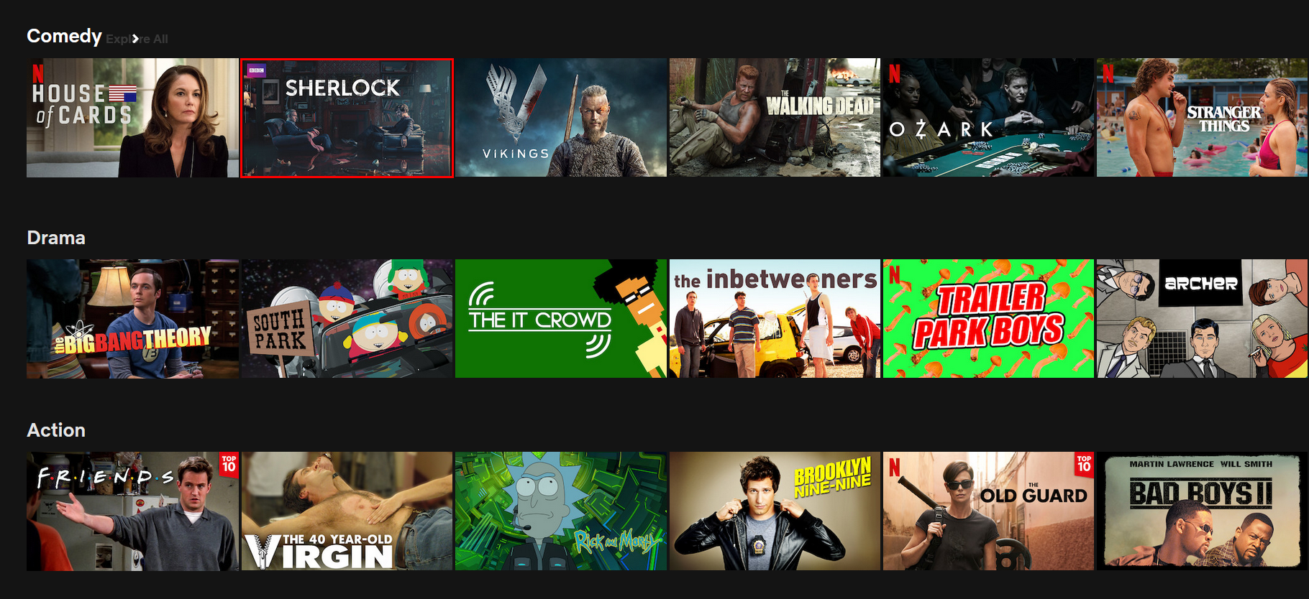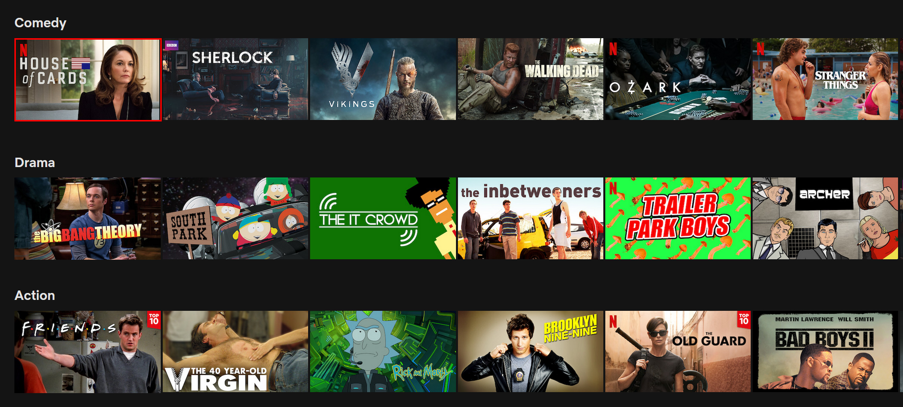

3.User clicks **Down** arrow, the selected movie will be “South park”.  
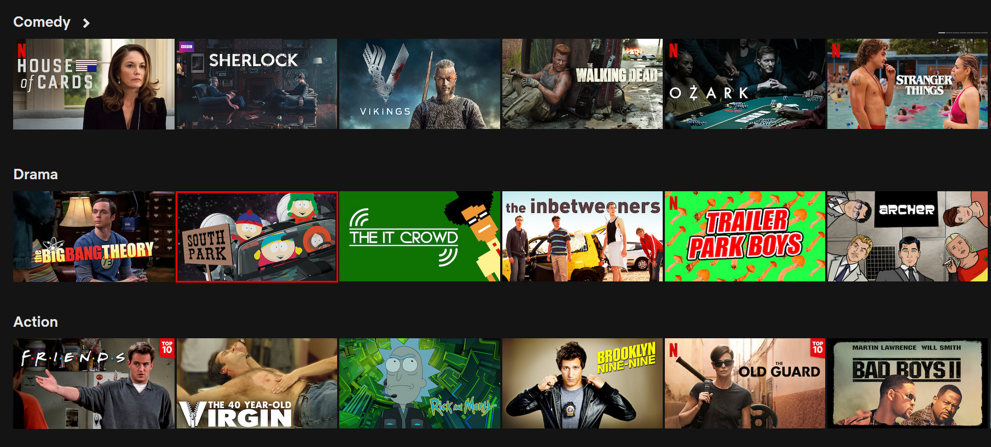

We are using [themoviedb API](https://developers.themoviedb.org/3/getting-started/introduction) for fetching movies by genre. Each genre is a separate API request. Genres that should be displayed will be listed in a JSON file. Genre consists of ID and NAME. ID will be used in API requests and NAME will be shown above each slider.

API KEY: **d38aa8716411ef7d8e9054b34a6678ac**

GET [https://api.themoviedb.org/3/discover/movie?with_genres={*GENRE_ID*}&api_key=d38aa8716411ef7d8e9054b34a6678ac](https://api.themoviedb.org/3/discover/movie?with_genres=%7Bgenre_id%7D&page=1&api_key=d38aa8716411ef7d8e9054b34a6678ac)

**Please be aware that genres.json** **can be changed ( new genres can be added and the old ones can be expelled). The application must display only genres that are in genres.json file.**  
  
Genres.json example:

"genres": [

{

"id": 28,

"name": "Action"

},

{

"id": 12,

"name": "Adventure"

},

{

"id": 16,

"name": "Animation"

},

{

"id": 35,

"name": "Comedy"

}

]

**You should create genres.json in your project and import it for further usage, it shouldn’t be hardcoded anywhere elsewhere in the application.**

**So if we want to add new genres when we review the test, they should be automatically rendered in the app.**

**Tasks**

1. Create a simple login page with a login form (username, password fields and submit button). Error handling should be done as displaying proper error messages (will be explained in steps under a,b,c).

**POST** [**http://dev.api.kabox.io/api/auth/login**](http://dev.api.kabox.io/api/auth/login)

**Body form-data:**

**“email”: <example@boopro.tech>**

**“password”: <123123>**

* 1. *email*: example@boopro.tech,   
     *password*: 123123  
       
     Use this form data to get a successful response (HTTP status code 200) and save “access_token” from response in local storage of the browser. After successful login user is able to access the home page (you should redirect him) with movie sliders described in next tasks.
  2. *email*: example@boopro.tech,   
     *password*: 111111  
       
     Use this form data to get an unsuccessful response (HTTP status code 401) in this case means that the account exists but password is not correct. Display the message from the response under the “error” key.
  3. *email*: someone@boopro.tech,   
     *password*: 111111  
       
     Use this form data to get an unsuccessful response (HTTP status code 422) in this case means that the account with that email does not exist in the system. Display the message from the response (under “email” key).

1. Create logic for moving between sliders and movies in sliders only with arrow keys.
2. On Enter press:
   1. Show popup for the selected movie (simple popup with movie “titlle”, “tagline”, “overview” and “vote_average” from api)
   2. Close popup on Esc keypress
3. API and pagination ( unfinished)
   1. For each genre [https://api.themoviedb.org/3/discover/movie?with_genres={genre_id}&page=1&api_key=d38aa8716411ef7d8e9054b34a6678ac](https://api.themoviedb.org/3/discover/movie?with_genres=%7Bgenre_id%7D&page=1&api_key=d38aa8716411ef7d8e9054b34a6678ac) (replace genre_id with ids from json genres.json above)
   2. Image URL should be generated as <https://image.tmdb.org/t/p/w500/> + poster_path from API
   3. Try to display 6 movies per slider on 1920x1080 resolution. For responsive you can choose between resizing movie cards or increasing/decreasing the number of movies per slide.
   4. When movie is in active state (focused), make borders red and display movie “title” beneath it.